Model the Data Flow: provide the code for plantuml for a Level 1 DFD showing processes like 'User Registration', 'Browse Products', and 'Place Order'. The DFD's data stores (Customers, Products, Orders) will directly map to the new schema in a beginner friendly manner.
To visualize how data moves between your users, the processes, and your database tables, a Level 1 Data Flow Diagram (DFD) is the perfect tool.
In a Level 1 DFD:
- Entities (Square) are the external actors (the User).
- Processes (Circle/Round Box) are the actions being taken.
- Data Stores (Open Rectangle) represent your SQL tables.
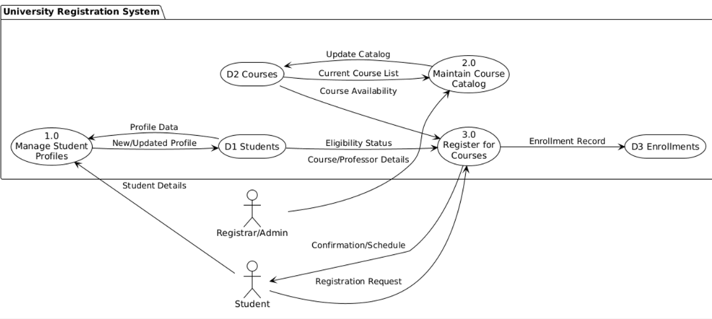
Mapping the DFD to your SQL Schema
To keep this beginner-friendly, here is how the "Data Flows" in the diagram translate to the SQL tables you just created:
DFD Process | Action | SQL Table Involved | Key Columns Used
User Registration | INSERT | Customers | CustomerID, Email
Browse Products | SELECT | Products, Categories | Name, Price, CategoryName
Place Order | INSERT | Orders, OrderItems | OrderID, ProductID, Quantity
How to read this flow:
- Registration: The user provides data that moves into the Customers data store.
- Browsing: Data flows out of the Products data store to the user so they can see what is available.
- Place Order: This is the most complex flow. It takes the CustomerID from the Customers table and the ProductID from the Products table to create new entries in the Orders and OrderItems tables.
A university's legacy registration system is being replaced.The goal is to create a modern, robust design that supports the university's processes. Generate a simple synthetic dataset for a single StudentCourse table might contain student details, course details, and professor details.
When moving from a legacy system to a modern database design, you often start with a "flat" table (like a spreadsheet) and then normalize it into the structured tables we used in your previous examples.
Below is a synthetic dataset representing that initial, unorganized state. This table contains redundant data (for example, the professor's name is repeated every time a course appears), which is exactly what a robust design aims to fix.
Synthetic Dataset: StudentCourse (Legacy Format)
StudentID | StudentName | Email | CourseID | CourseName | ProfessorName | Semester
1001 | Alice Vance | alice@uni.edu | CS101 | Intro to SQL | Dr. Aris Totle | Fall 2024
1002 | Bob Miller | bob.m@uni.edu | CS101 | Intro to SQL | Dr. Aris Totle | Fall 2024
1001 | Alice Vance | alice@uni.edu | BIO200 | Genetics | Dr. Rosalind F. | Fall 2024
1003 | Clara Hsu | clara@uni.edu | MATH10 | Calculus I | Dr. Isaac N. | Spring 2025
1002 | Bob Miller | bob.m@uni.edu | MATH10 | Calculus I | Dr. Isaac N. | Spring 2025

SQL Command to Create and Populate (VS Code)
You can run this script to simulate the legacy data before you begin the process of "Normalizing" it into separate tables for Students, Courses, and Professors.
SQL
-- Create the flat legacy table
CREATE TABLE StudentCourse (
ID INTEGER PRIMARY KEY AUTOINCREMENT,
StudentID INT,
StudentName VARCHAR(100),
Email VARCHAR(100),
CourseID VARCHAR(10),
CourseName VARCHAR(100),
ProfessorName VARCHAR(100),
Semester VARCHAR(20)
);

-- Insert synthetic data
INSERT INTO StudentCourse (StudentID, StudentName, Email, CourseID, CourseName, ProfessorName, Semester) VALUES
(1001, 'Alice Vance', 'alice@uni.edu', 'CS101', 'Intro to SQL', 'Dr. Aris Totle', 'Fall 2024'),
(1002, 'Bob Miller', 'bob.m@uni.edu', 'CS101', 'Intro to SQL', 'Dr. Aris Totle', 'Fall 2024'),
(1001, 'Alice Vance', 'alice@uni.edu', 'BIO200', 'Genetics', 'Dr. Rosalind F.', 'Fall 2024'),
(1003, 'Clara Hsu', 'clara@uni.edu', 'MATH10', 'Calculus I', 'Dr. Isaac N.', 'Spring 2025'),
(1002, 'Bob Miller', 'bob.m@uni.edu', 'MATH10', 'Calculus I', 'Dr. Isaac N.', 'Spring 2025');

Why this design needs "Modernizing"
If you look closely at the data above, you'll see a few issues that a robust design would solve:
- Redundancy: If Dr. Aris Totle changes their name or leaves, you have to update every single row where CS101 appears.
- Data Integrity: If Alice Vance changes her email, you might update it in the CS101 row but forget the BIO200 row, leading to conflicting data.
- Growth: This table doesn't easily handle a course having multiple professors or a student having a minor/major.
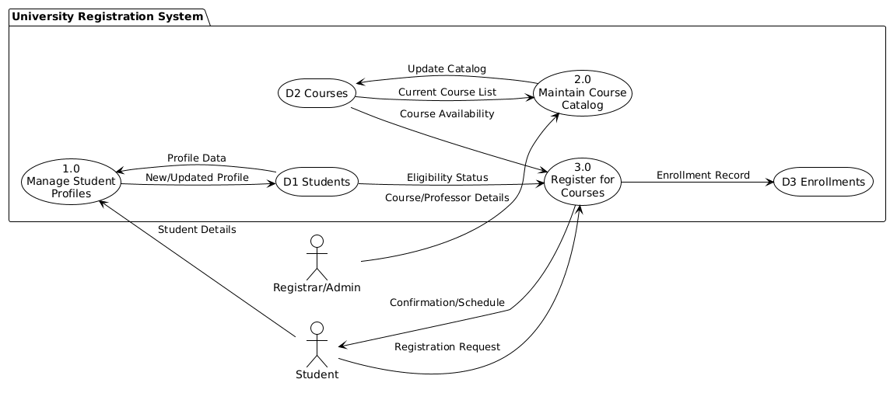

In a formal Level 1 Data Flow Diagram (DFD), we focus on how data moves between the major processes of the system. According to standard conventions (like Gane-Sarson or Yourdon), we use specific shapes:
- Squares: External Entities (Actors).
- Rounded Rectangles: Processes (numbered).
- Open-ended Rectangles: Data Stores (Tables).
- Arrows: Data Flows (labeled with the specific data being moved).

Key Data Flow Breakdown
Process | Inputs | Outputs | Purpose
1.0 Manage Profiles | Student Details | Student Record (D1) | Translates "StudentName" and "Email" from your legacy table into a permanent record.
2.0 Maintain Catalog | Professor/Course Info | Course Record (D2) | Handles the "CourseName" and "ProfessorName" independently from specific students.
3.0 Register | Enrollment Request | Enrollment Record (D3) | The "Bridge" process that links a specific StudentID to a CourseID.
To modernize that legacy StudentCourse table, we need to apply Normalization. This involves breaking the flat table into three distinct entities to eliminate redundancy.
The Normalized Schema (3rd Normal Form)
Instead of one giant table, we create three. This ensures that if a professor changes their name, you only update it in one place (the Courses table), rather than in every row where a student is enrolled.
-- 1. Students Table (Personal info only)
CREATE TABLE Students (
StudentID INT PRIMARY KEY,
StudentName VARCHAR(100),
Email VARCHAR(100) UNIQUE
);

-- 2. Courses Table (Course and Professor info only)
CREATE TABLE Courses (
CourseID VARCHAR(10) PRIMARY KEY,
CourseName VARCHAR(100),
ProfessorName VARCHAR(100)
);

-- 3. Enrollments Table (The "Bridge" table linking them)
CREATE TABLE Enrollments (
EnrollmentID INTEGER PRIMARY KEY AUTOINCREMENT,
StudentID INT,
CourseID VARCHAR(10),
Semester VARCHAR(20),
FOREIGN KEY (StudentID) REFERENCES Students(StudentID),
FOREIGN KEY (CourseID) REFERENCES Courses(CourseID)
);
Migration: Inserting the Synthetic Data
Here is how that same legacy data is distributed across the new, robust structure. You can run these in VS Code to see the difference:
-- Populate Students
INSERT INTO Students (StudentID, StudentName, Email) VALUES
(1001, 'Alice Vance', 'alice@uni.edu'),
(1002, 'Bob Miller', 'bob.m@uni.edu'),
(1003, 'Clara Hsu', 'clara@uni.edu');

-- Populate Courses
INSERT INTO Courses (CourseID, CourseName, ProfessorName) VALUES
('CS101', 'Intro to SQL', 'Dr. Aris Totle'),
('BIO200', 'Genetics', 'Dr. Rosalind F.'),
('MATH10', 'Calculus I', 'Dr. Isaac N.');

-- Populate Enrollments (Linking them together)
INSERT INTO Enrollments (StudentID, CourseID, Semester) VALUES
(1001, 'CS101', 'Fall 2024'),
(1002, 'CS101', 'Fall 2024'),
(1001, 'BIO200', 'Fall 2024'),
(1003, 'MATH10', 'Spring 2025'),
(1002, 'MATH10', 'Spring 2025');
Comparison: Legacy vs. Modern
Feature | Legacy Table | Modern (Normalized)
Storage | Highly Redundant (Repeats Names/Emails) | Efficient (Data stored once)
Updates | Update many rows (Risk of errors) | Update one row (Data Integrity)
Scalability | Difficult to add new attributes | Easy to extend (e.g., adding a 'Gpa' column)
Moving to a Third Normal Form (3NF) schema is the gold standard for university registration systems. It ensures that every non-key column is dependent only on the Primary Key, eliminating data anomalies.
Entity Relationship Diagram (ERD)
The ERD below visualizes the relationship between your entities. Note the one-to-many relationships: one student can have many enrollments, and one course can have many students enrolled.
The 3NF SQL Schema
In this version, I have added a Professors table. In your legacy data, the professor's name was tied to the course. In 3NF, we separate them so a professor can exist even if they aren't currently teaching a course, and a course can exist without a professor assigned yet.
-- 1. Professors Table
CREATE TABLE Professors (
ProfessorID INTEGER PRIMARY KEY AUTOINCREMENT,
ProfessorName VARCHAR(100) NOT NULL,
Department VARCHAR(100)
);

-- 2. Students Table
CREATE TABLE Students (
StudentID INT PRIMARY KEY,
StudentName VARCHAR(100) NOT NULL,
Email VARCHAR(100) UNIQUE NOT NULL
);

-- 3. Courses Table
CREATE TABLE Courses (
CourseID VARCHAR(10) PRIMARY KEY,
CourseName VARCHAR(100) NOT NULL,
ProfessorID INT,
FOREIGN KEY (ProfessorID) REFERENCES Professors(ProfessorID)
);

-- 4. Enrollments Table (The Junction Table)
CREATE TABLE Enrollments (
EnrollmentID INTEGER PRIMARY KEY AUTOINCREMENT,
StudentID INT,
CourseID VARCHAR(10),
Semester VARCHAR(20),
Grade VARCHAR(2),
FOREIGN KEY (StudentID) REFERENCES Students(StudentID),
FOREIGN KEY (CourseID) REFERENCES Courses(CourseID)
);
Moving to a Third Normal Form (3NF) schema is the gold standard for university registration systems. It ensures that every non-key column is dependent only on the Primary Key, eliminating data anomalies.
Entity Relationship Diagram (ERD)
The ERD below visualizes the relationship between your entities. Note the one-to-many relationships: one student can have many enrollments, and one course can have many students enrolled.

The 3NF SQL Schema
In this version, I have added a Professors table. In your legacy data, the professor's name was tied to the course. In 3NF, we separate them so a professor can exist even if they aren't currently teaching a course, and a course can exist without a professor assigned yet.
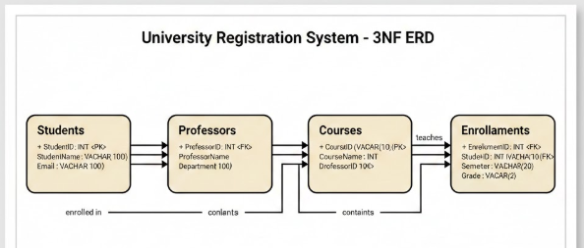
Sample Data Insertion
Here is how you would populate this normalized structure in VS Code:
-- Insert Professors
INSERT INTO Professors (ProfessorName, Department) VALUES
('Dr. Aris Totle', 'Computer Science'),
('Dr. Rosalind F.', 'Biology'),
('Dr. Isaac N.', 'Mathematics');

-- Insert Students
INSERT INTO Students (StudentID, StudentName, Email) VALUES
(1001, 'Alice Vance', 'alice@uni.edu'),
(1002, 'Bob Miller', 'bob.m@uni.edu');

-- Insert Courses (linking ProfessorID 1 to CS101)
INSERT INTO Courses (CourseID, CourseName, ProfessorID) VALUES
('CS101', 'Intro to SQL', 1),
('BIO200', 'Genetics', 2);

-- Insert Enrollments
INSERT INTO Enrollments (StudentID, CourseID, Semester) VALUES
(1001, 'CS101', 'Fall 2024'),
(1002, 'CS101', 'Fall 2024');

